

**GBTA Hotel Committee RFP “How To” Overview**

**Collecting / Reviewing Hotel Responses**

**PURPOSE**

This document will demonstrate the mechanics of how a GBTA format file received from a hotel(s) can be imported to the “GBTA Hotel RFP Pal” for effective analysis and comparison.

For Direct Members who have not had a formal method for approaching the market, the GBTA Hotel RFP Global Format 2013 will streamline the collection and review of data for programs in their infancy.

Hotel responses contained in the 7 module, 717 field format can be filtered, in order to focus solely on the Direct Member’s unique program needs, effectively resulting in their own "Short Form".

**TOOLS / DOCUMENTS**

Attached zip file contains:

* GBTA Hotel RFP Global Format 2013 - Glossary (.pdf)
* GBTA Hotel RFP Global Format 2013 - Summer2013 (.xlsx)
* GBTA Hotel RFP Pal (.xlsx)

**STEP 1: DEFINE THE FIELDS RELEVANT TO YOUR HOTEL PROGRAM**

TOOLS: GBTA Hotel RFP Global Format 2013 – Glossary (.pdf)

GBTA Hotel RFP Global Format 2013 – Summer 2013 (.xlsx)

\

Both the above referenced Tools provide a complete list of 717 fields collected via the GBTA Hotel RFP Global Format.

Using either document, prepare a list of the Field Numbers (questions) that are a priority for you.

When sending your bid packet to Suppliers, it is recommended you communicate to the Hotels that these are the fields of interest to you.

NOTE: if you have User Defined Questions, include the applicable field numbers in your review as well.

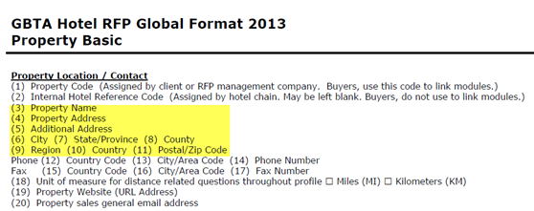

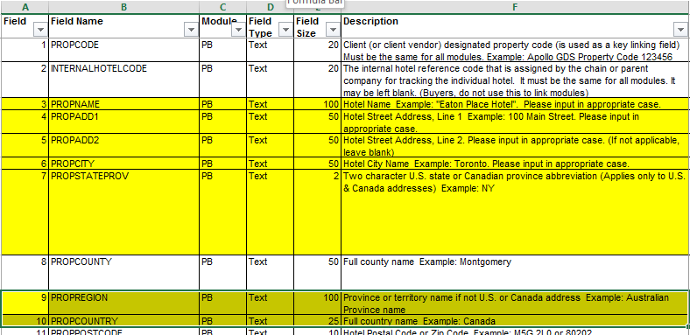

**STEP 2: FLAG THESE RELEVANT FIELDS FOR REVIEW IN THE “GBTA Hotel RFP PAL”**

TOOLS: GBTA Hotel RFP Pal (.xlsx)

In column “A” of the RFP Pal, enter an “X” for the fields identified based on your review in Step 1. It is easiest to cross reference these by Field Number.

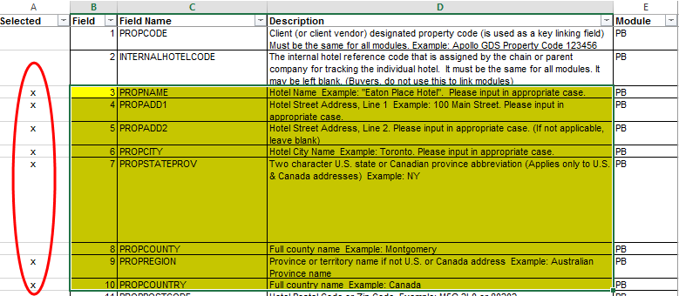

**STEP 3: FILE SUBMISSIONS FROM HOTELS**

TOOLS: Microsoft Excel

In your bid instructions to Hotels, request that responses be submitted in one of the following formats:

**.CSV File**

* Field Headers included for all fields
* Single string of data, including all 717 fields

**.TXT (Text) File**

* Field Headers included for all fields
* Single string of data, including all 717 fields

If you receive a text file, save it to your computer with a .CSV extension (instead of .TXT).

**STEP 4: IMPORT HOTEL RESPONSES TO THE “GBTA Hotel RFP Pal”**

TOOLS: GBTA Hotel RFP Pal (.xlsx) (same as updated in Step 2)

Hotel .CSV response file

Opening the .CSV, highlight the rows of data. Hit “Ctrl + C” to copy

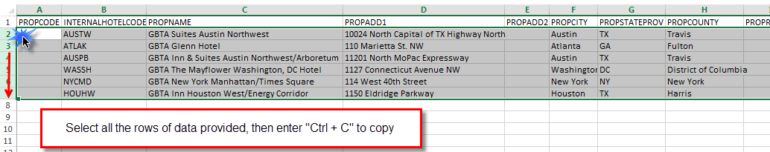

Navigating to your RFP Pal (from Step 2), place the cursor in row 2 of the first column you want populated with hotel data.

Navigate to Paste | Special| Transpose

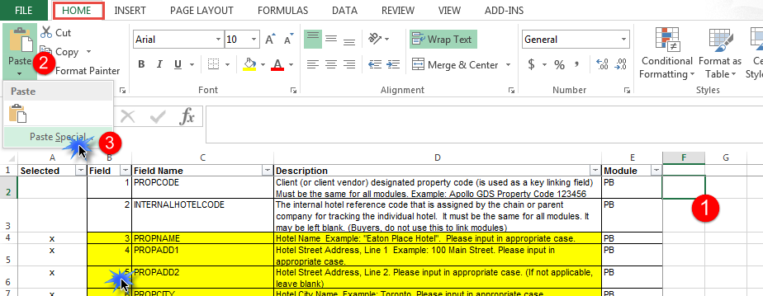

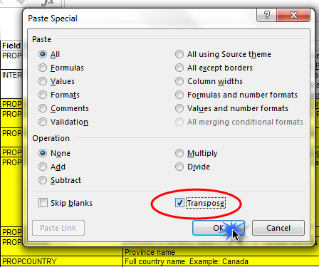

The data displays in vertical columns

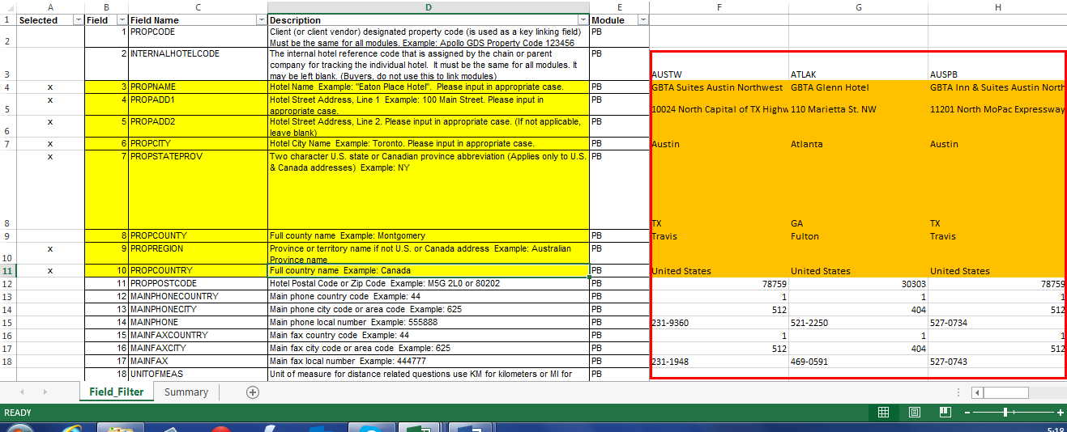

Click on cell A1, named “Selected” and activate the option to use filters

In Cell A1, filter for “X”

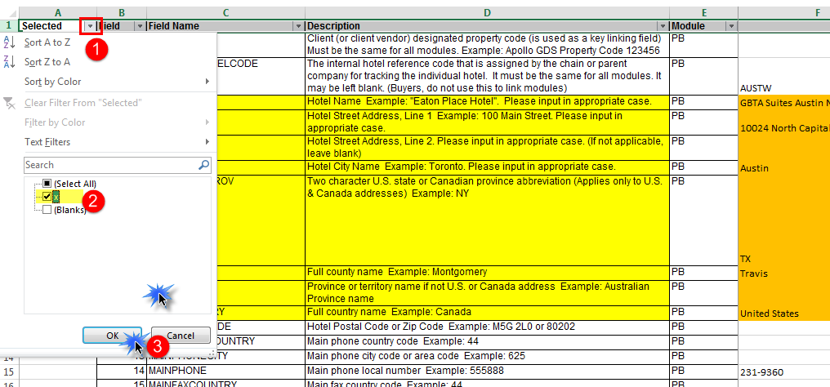

The RFP PAL now displays only those fields relevant to your program!

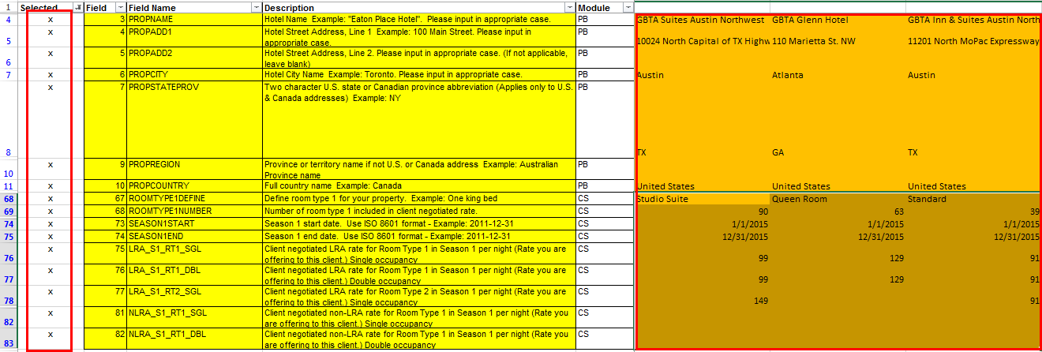

**STEP 5: NEED TO MODIFYING FIELDS REVIEWED**

TOOLS: GBTA Hotel RFP Pal (.xlsx) (same as updated in Steps 2 & 4)

If need to remove/add fields to your review, return to cell A1, “Selected”, select all items.

Add/remove “X” as desired.

Click on cell A1, named “Selected” and activate the option to use filters

In Cell A1, filter for “X”

Scroll left to right to read, review and compare all hotel responses.